**Developing a Flight Delay Prediction Model using Machine Learning.**

### Technology Architecture

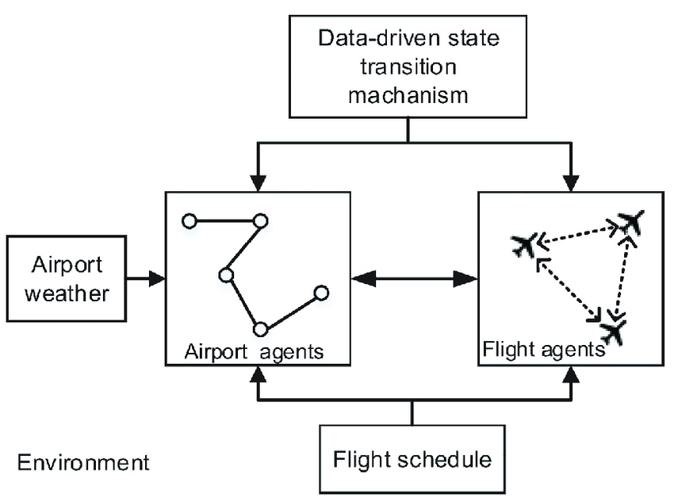

Prior work has used simulation to investigate air traffic delay. However, these studies have notemphatically focused on the real-time parameters that significantly affect flight delay. Hence, itis difficult to apply these studies to flight delay prediction in the tactical phase. To fill this gap,we proposed a method combining simulation and data mining aiming to predict flight delaysin the entire air traffic system in the future. In particular, an agent-based model was con-structed, and several crucial time-varying parameters affected agent states obtained by datamining methods.